* Below are details of Upload bcon files from devops m/c to nexus & downloading same in Jenkins & deployed using UCd to lbgjvtapp116 machine.
* Solution architecture & implemented is part of attached Ppt.

Uploading steps:



1. Remove previous files if any under **/t24/delbuild/thirdparty/bcon**
2. Place bcon files under **/t24/delbuild/thirdparty/bcon** directory.

**Note:**

* Files must be in .tar.gz format
* You must need to wipe out prior deployed ones, so as to consider fresh bcon files.

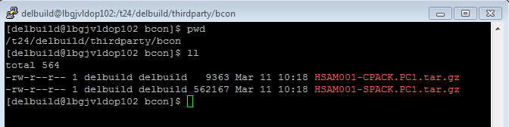

1. Go to **/t24/delbuild/thirdparty/Scripts** and run **./upload_bcon_files_to_nexus.ksh** script.

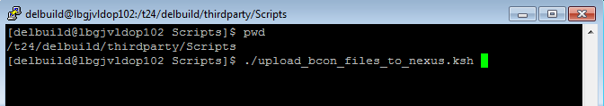

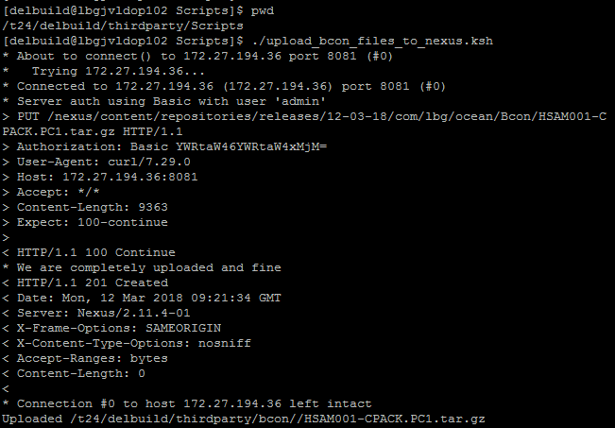

1. Post run, you can have a look at Nexus :

<http://172.27.194.36:8081/nexus/#view-repositories;releases~browsestorage>

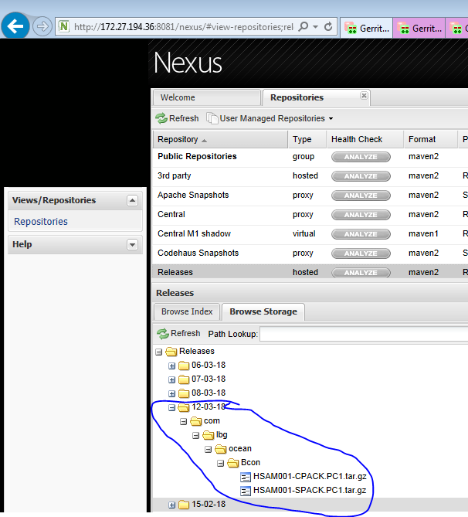

**NOTE:**

* You should run Jenkins job on the same day, when you upload files into nexus by using script

(Jenkins job looks for current date)

* Overwrite functionality is not supported in Nexus under same release build folder. Remove from nexus (right click on Bcon folder and select delete. )

**Jenkins steps:**

**Jenkins job:** deploy_becon_files

* This job will place bcon files into lbgjvtapp116 m/c (TEM_ENV5)

<http://172.27.194.36:9200/job/deploy%20artefacts/job/deploy_becon_files/>

* Click on above link it will redirect to Jenkins job
* Click on build now
* Then by using ucd snapshot method you can place bcon files in to required environment whenever it needed

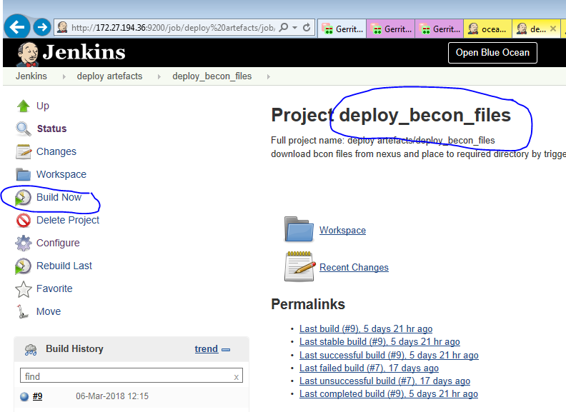

* Here is snap from UCd Component process which has been run in automated fashion from Jenkins build

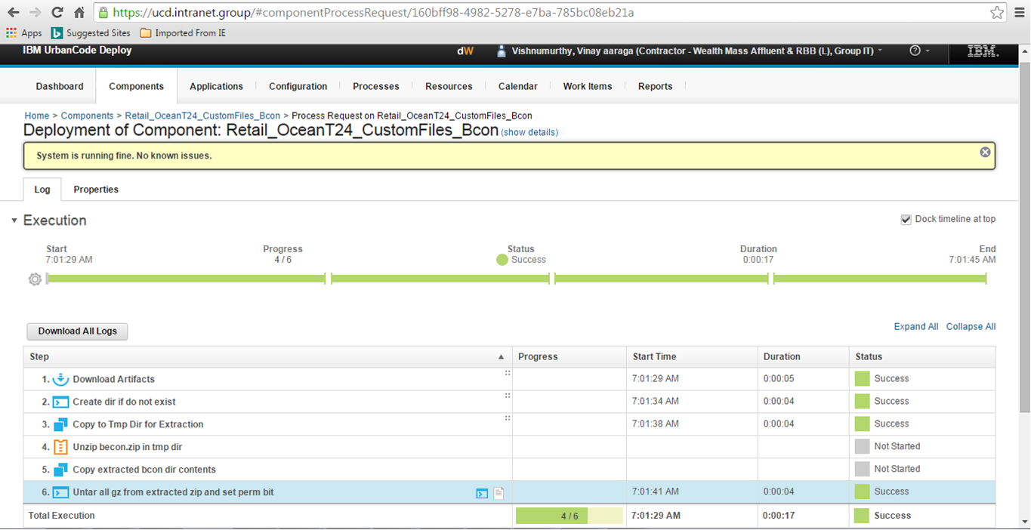

* After this based on requirement you can deploy the latest/old version in required environment.

Go to Below link

<https://ucd.intranet.group/#application/865cc0af-2f37-4dd6-aa37-25816de1053f>

**login with fileId and password**

you can see below screen shot

1. Select environment where you want to deploy and click on play button (see below screen shot no.1)
2. Select the process **(Ocean - Deploy bcon_files)**
3. Click on **choose versions**
4. Click on Add button and select **latest version**
5. Click **Ok**
6. Click on **submit**

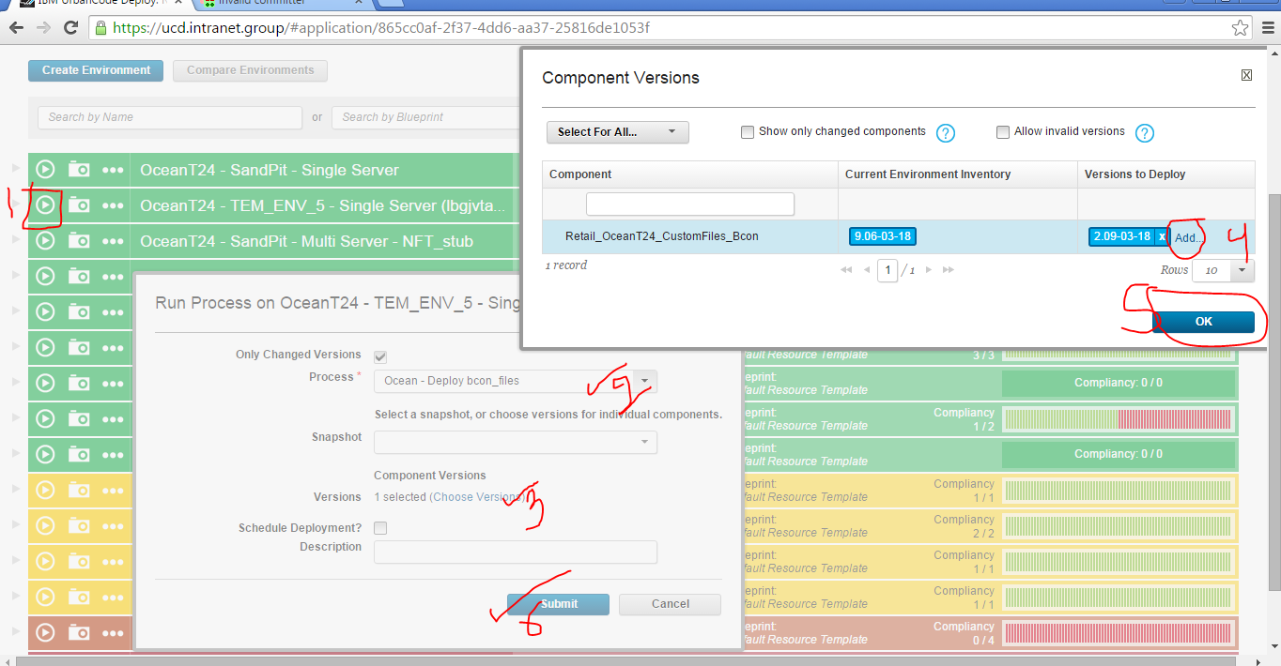

If it pre-prod/prod it goes for approval, ask person who have approve access.